Project Report Templates

JOB APPLICATION TRACKING SYSTEM

1. INTRODUCTION
   1. Overview

When you apply for a job, you will fill out an application. Your application is just as important as your resume. Both the resume and the application are important tools in the job hunting process. They help the employer get a good understanding of who you are, what you have done and what you can do for them. The application is another step in the process that can help you get closer to getting the job.

* 1. purpose

The purpose of a resume is to sell yourself as the right person for the job and to help you get a job interview. The job application is often used in the same way. Similar to your resume, the job application is used by employers as a way to screen potential employees. You want your application to stand out from all of the others. You also don’t want to do something that will give the employer a reason to screen you out. It’s important to be prepared and do a good job filling out the application.

1. Problem Definition & Design Thinking

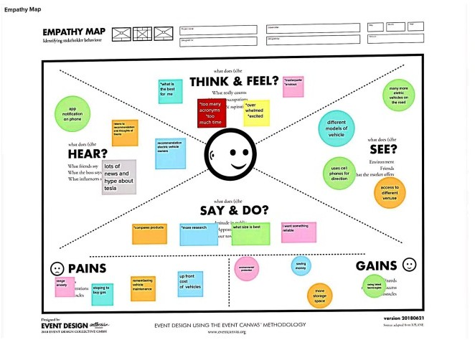

2.2 Ideation & Brainstroming Map

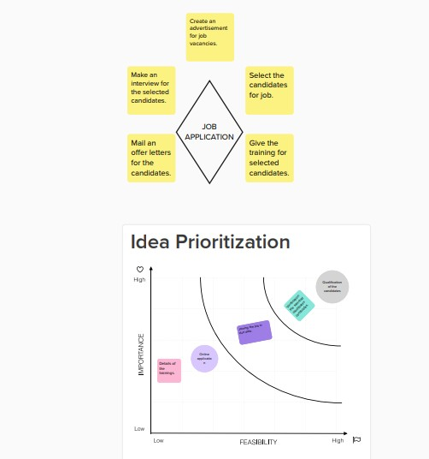

RESULT

* 1. Data model:

|  |  |
| --- | --- |
| Object name | Fields in the object |
| Object:1  Recruiter | Field label - Recruiter  Data type -Auto number |
| Object:2  Job | Field label - Job  Data type - Text |
| Object:3  Candidate | Field label - Candidate  Data type - Text |
| Object:4  Job application | Field label - Job application Data type - Text |

* 1. Activity & Screenshot

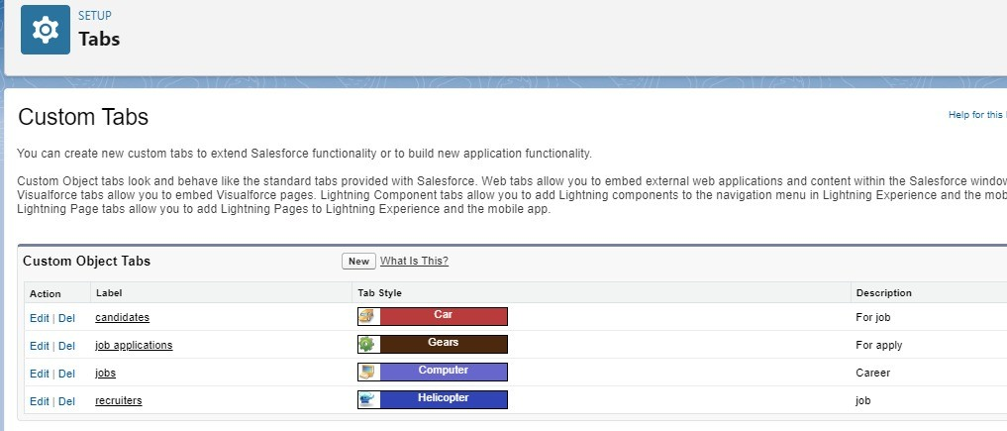

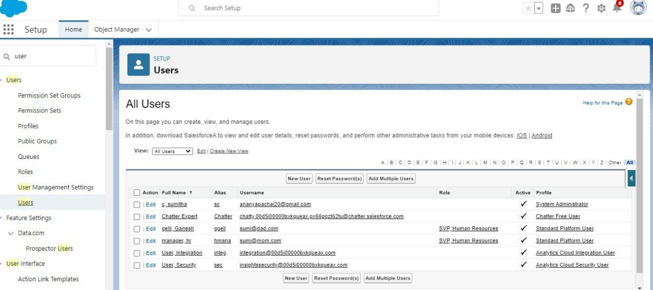

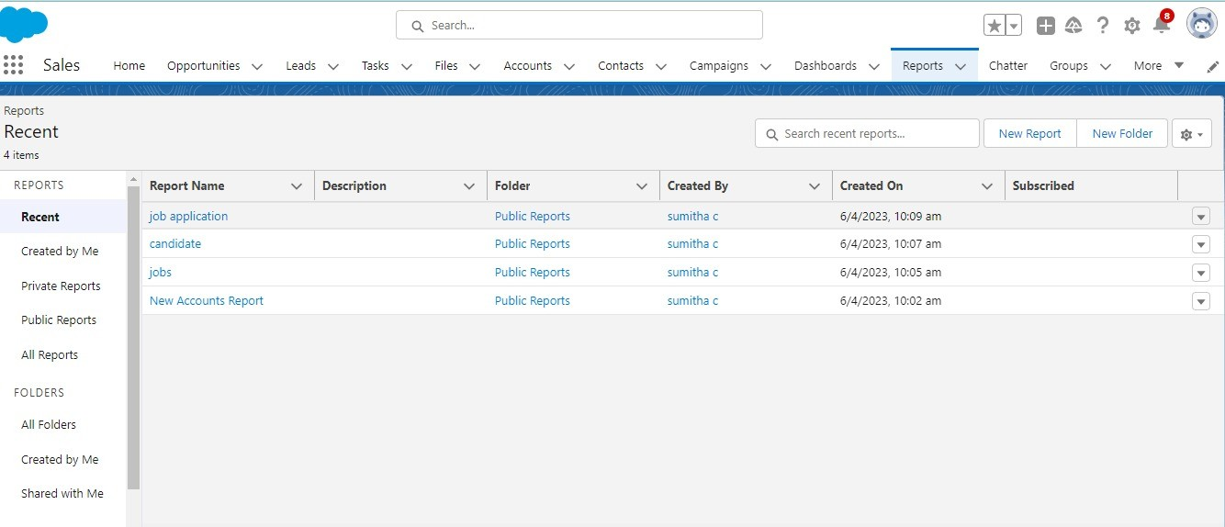

1. Trailhead profile public URL

Team lead - https://trailblazer.me/id/vedim1 Team Member 1 - https://trailblazer.me/id/kartr81Team Member 2 - https://trailblazer.me/id/govin170

Team Member 3 - https://trailblazer.me/id/vyadav533

1. Advantage & Disadvantage Advantages:
   1. Gain deeper cand date knowledge

Application forms allow recruiters to gain far deeper knowledge on applicants than you’d get from a CV or cover letter. Recruiters can ask specific questions on exact information they need to know for the role.

* 1. Background checks

A background check can be completed on applicants very early on in the recruitment process.

Disadvantages:

Time consuming to design

Creating a new job application form can be extremely time consuming and sometimes difficult to decide what questions are the best to ask.

1. Applications

The intelligent application of the latest technology and techniques to address specific workflow, production and post-production requirements will always increase productivity and quality while reducing costs.

1. Conclusion

Communicate the importance of your

ideas and the subject matter. Provide the reader with a sense of closure. Reiterate and summarize your main points. Rephrase and then restate your thesis statement.

1. Future scope

A job may be important for a sense of purpose since it can provide goals to work toward each day and an income to support you financially. It can help you build skills and experience that will last throughout your career, even if you change careers later in life.

THANK YOU.